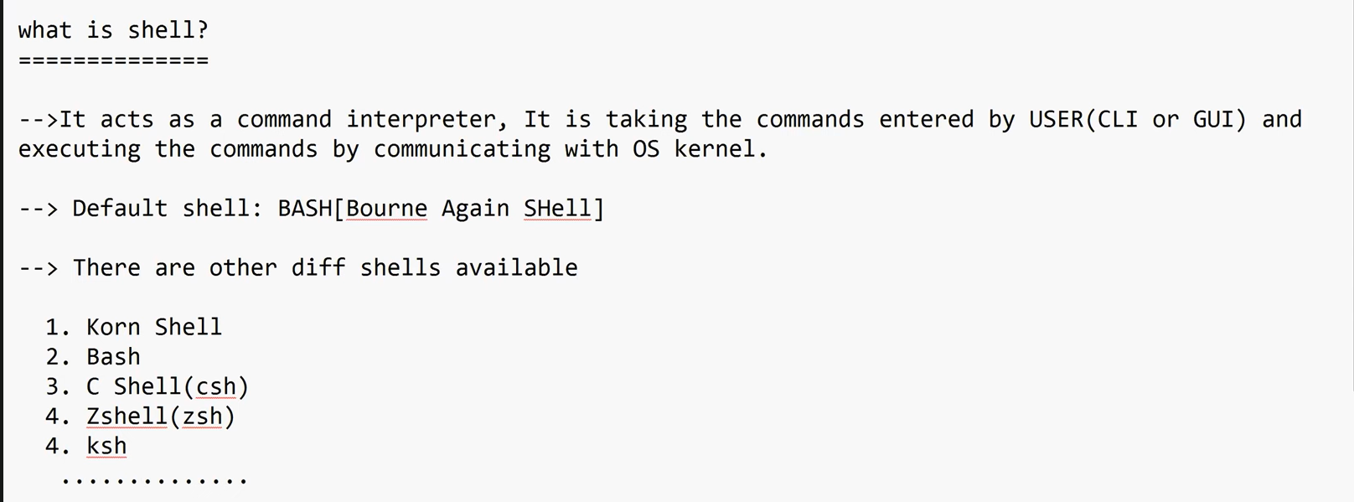
In order to check the Executed Linux commands History we have to execute the below command in the
downloads directory where we can find the command related to SSH as shown in the below image
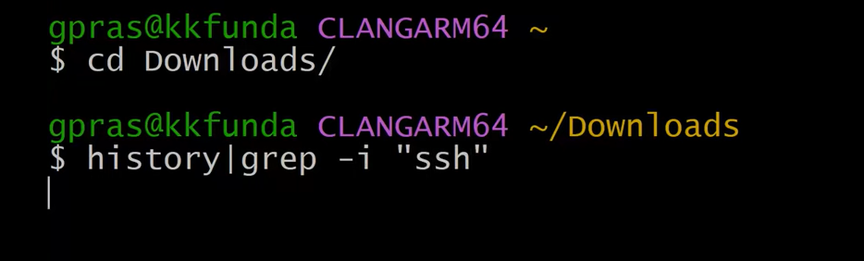
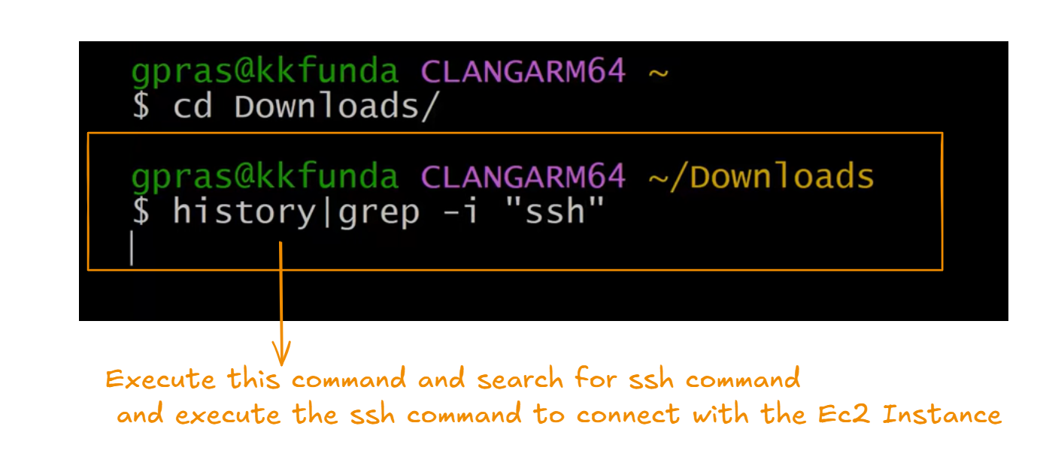
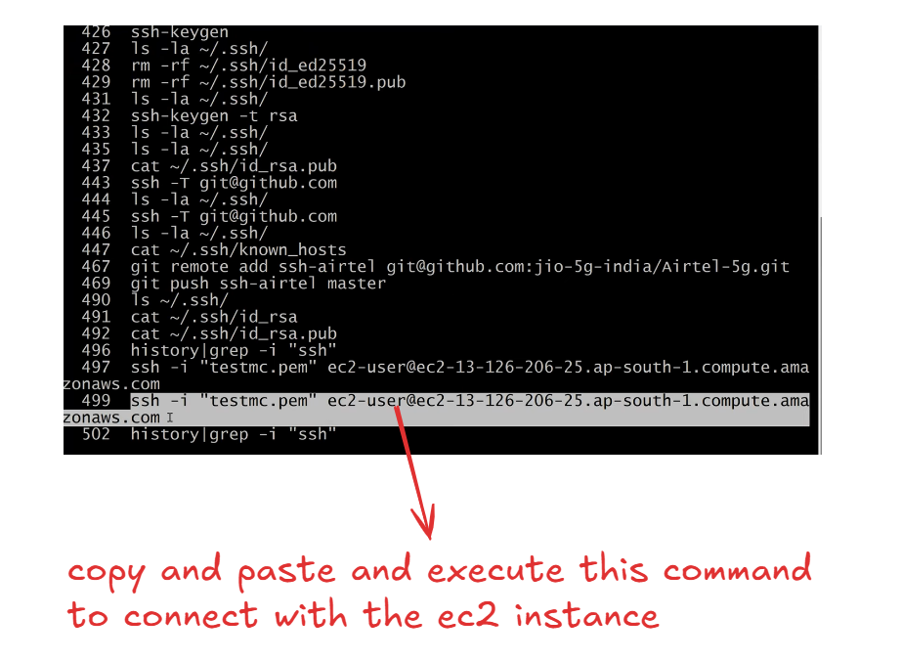
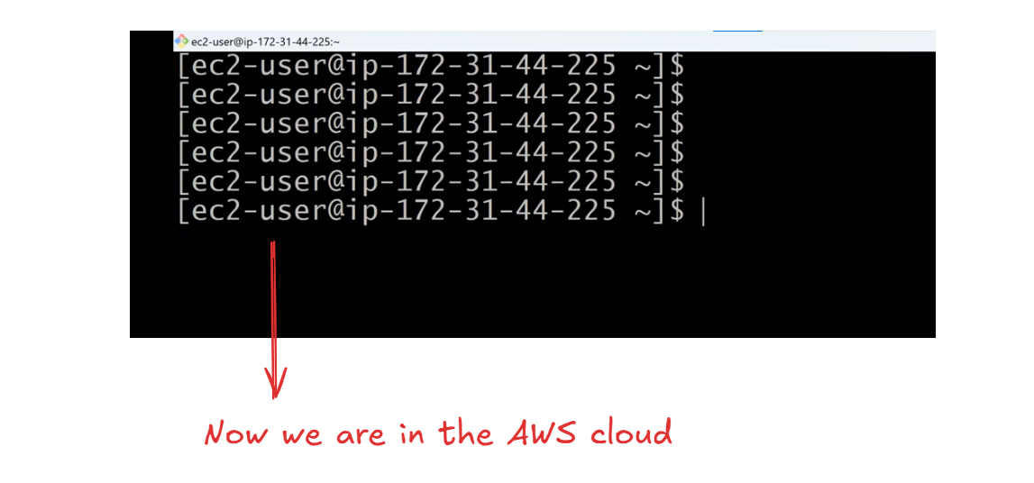
In order to check How many shells are there in my ec2 Instances we have to navigate to the /shells directory & execute the below command as shown in the below diagram
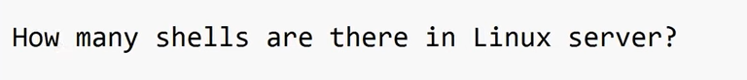
Generally all the shells info are stored in etc directory inside the shells file we have to cat the shells file as shown in the below image
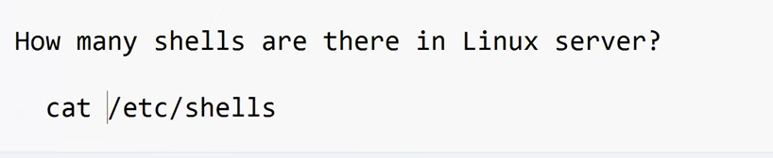
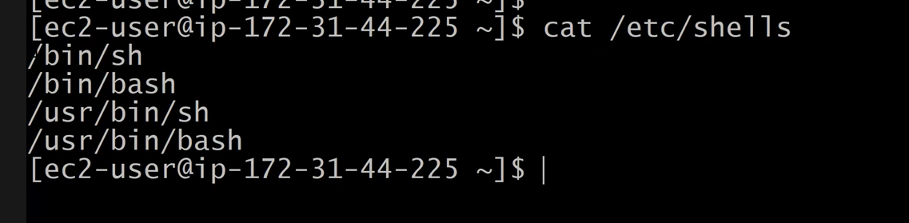
There are two shells present in our Ec2 Instance 1)sh shell and 2)bash shell as shown in the above Image
Execute the below command for installing other shells(csh,korn,Zshel)
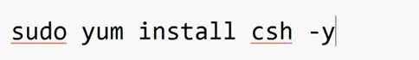
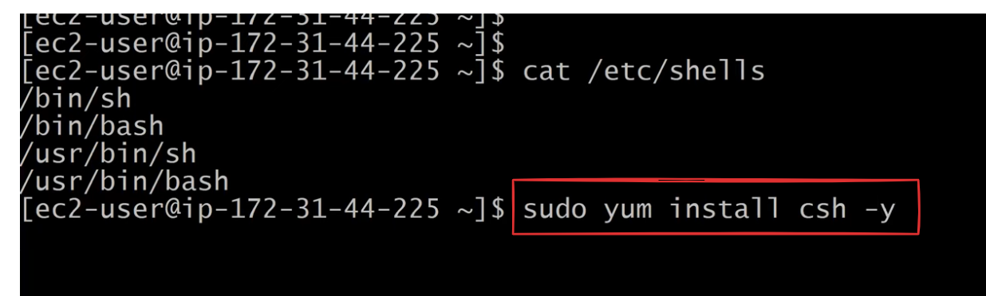
Execute cat command to check the shells list
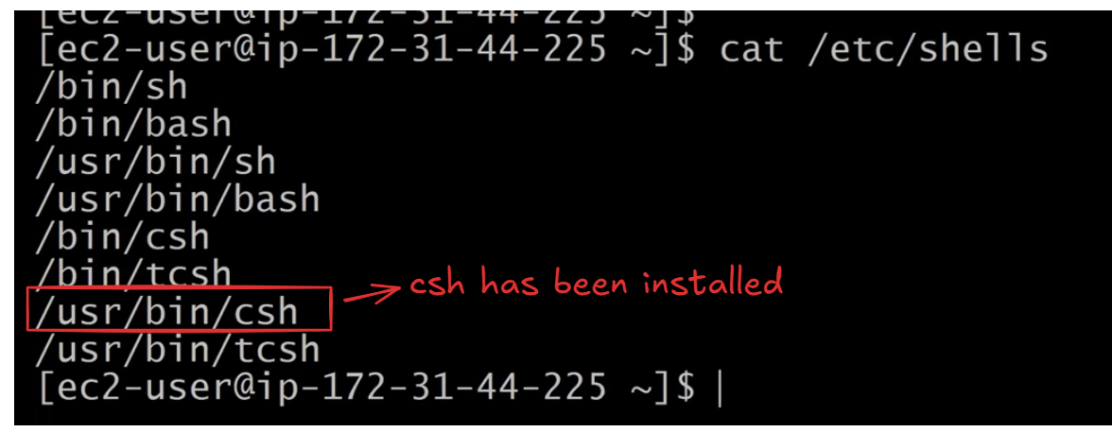
How to check Which shell we are using ?
We have to execute the command echo $SHELL (represent default shell not the using shell )or echo $0 or ps –p $$(shows the current shell in use) to check the current shell that we are using as shown in the below image
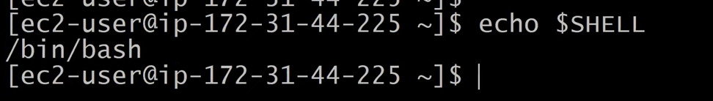
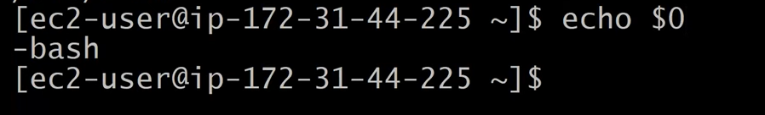
we can also use env command to check the current shell.
How to switch from one shell to another shell ?
1) First check the types of shells are present in our Linux Instance by executing the command
1) cat /etc/shells
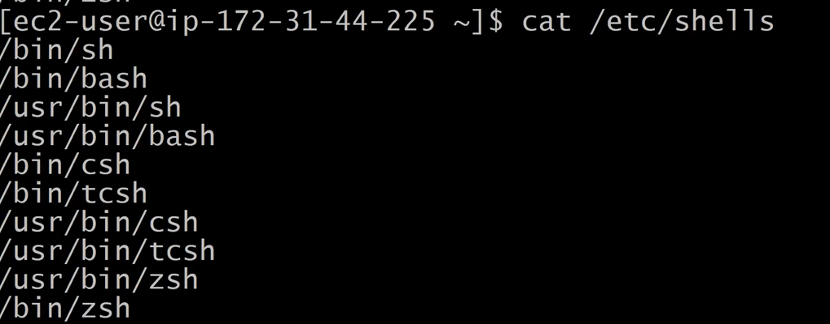
2) check the cureent shell by executing echo $0
3) execute the below command /bin/csh or /bin/bash
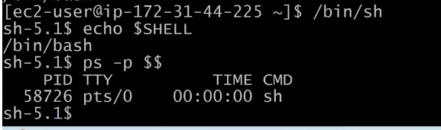
What is shell scripting ?
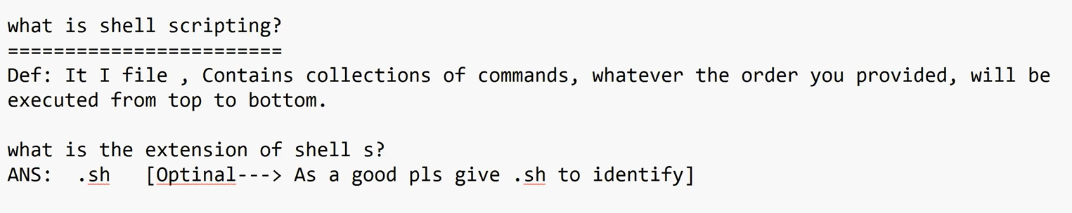
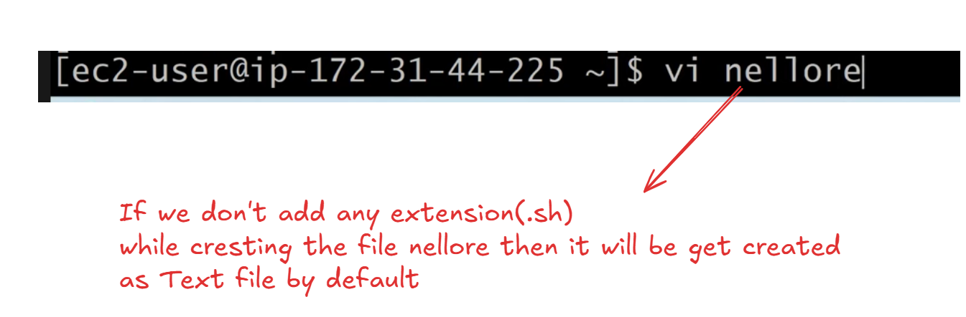
But add extension while creating any shell script
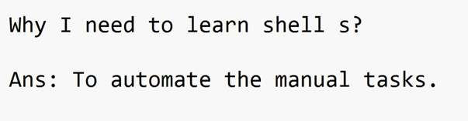
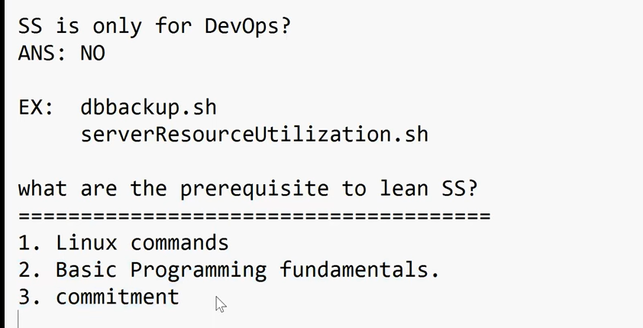
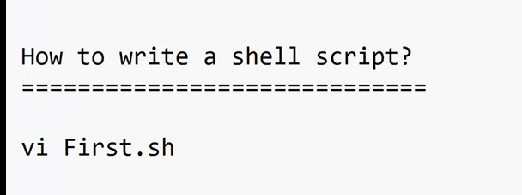
Lets create First.sh shell script and add some commands
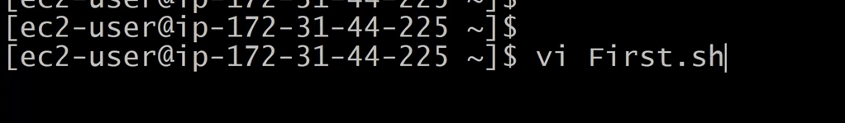
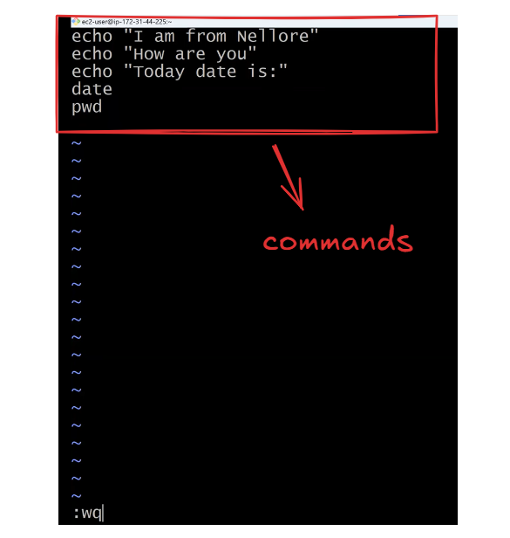
We can execute the shell script by using multiple ways as shown below
1) sh First.sh
2) ./First.sh
3) . First.sh
4) bash First.sh
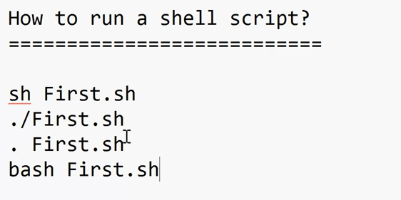
Give the Execute permission to the user(ec2-user) to execute the First.sh File as shown below
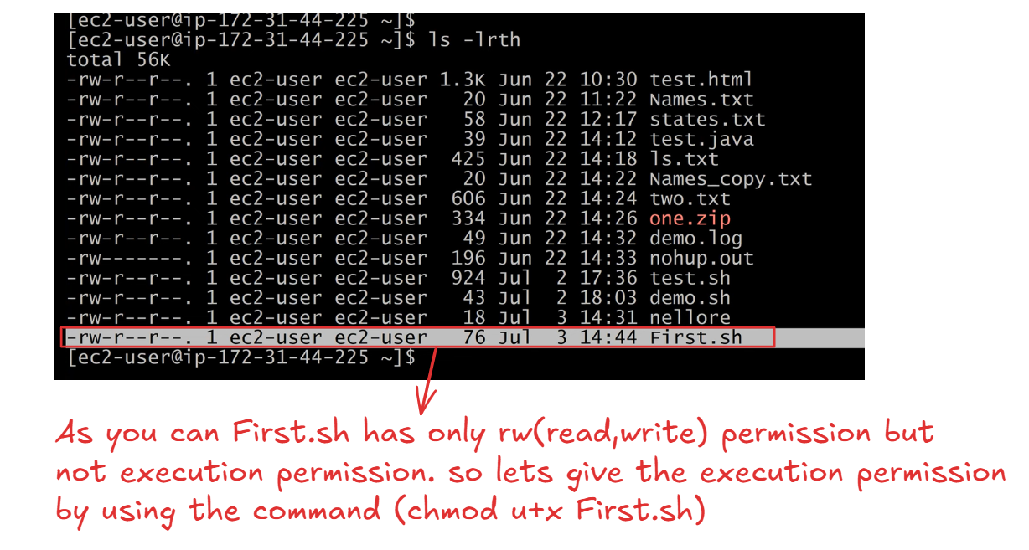
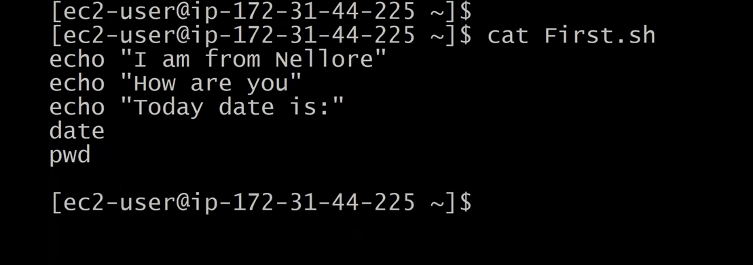
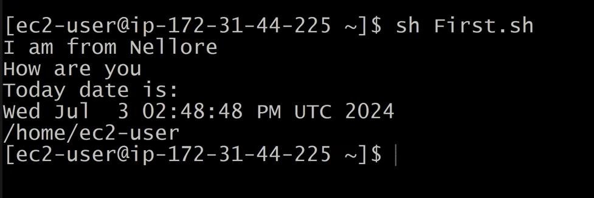
For sh First.sh does not require execute permission
but for ./First.sh Requires Permission Then we to add execute permission by executing the command (chmod u+x First.sh)
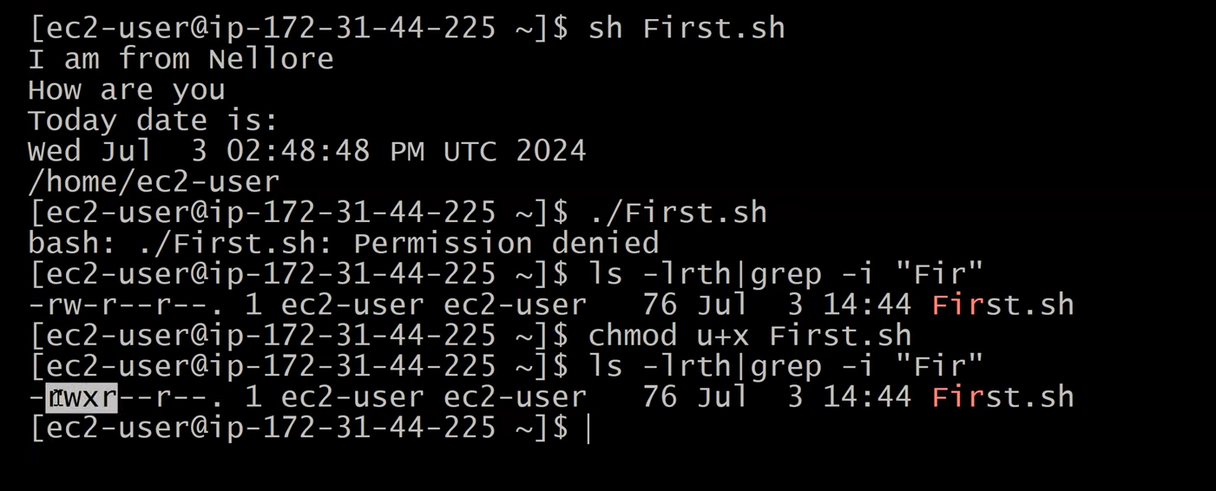
Any one we can use
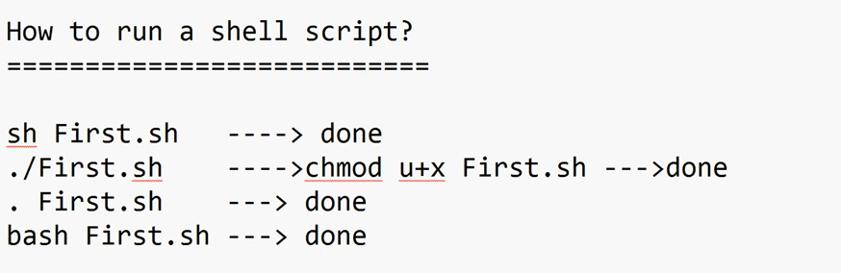
In our Shell script (First.sh) we have added Multiple commands as shown in the below image
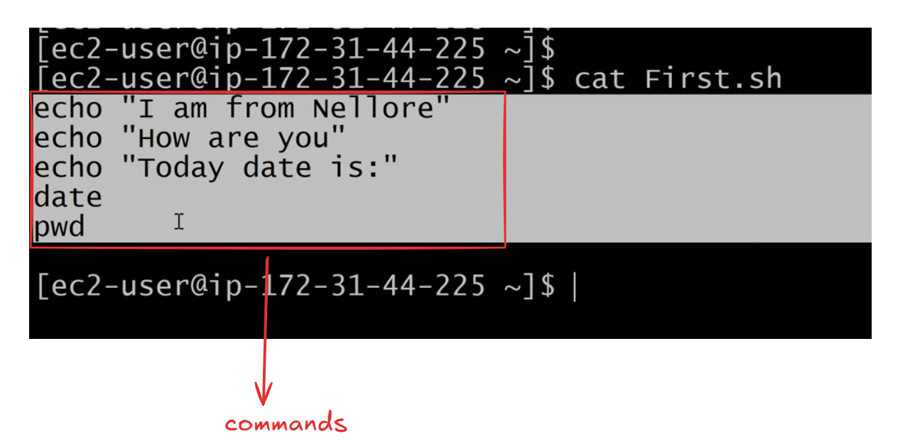
Lets add few more Linux commands in First.sh as shown in the below image
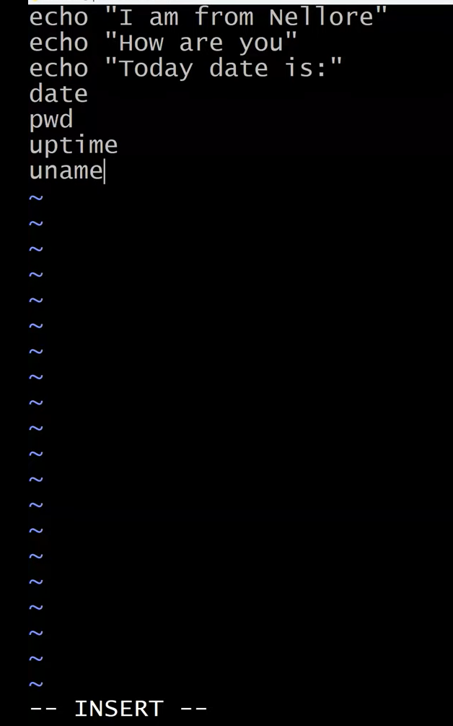
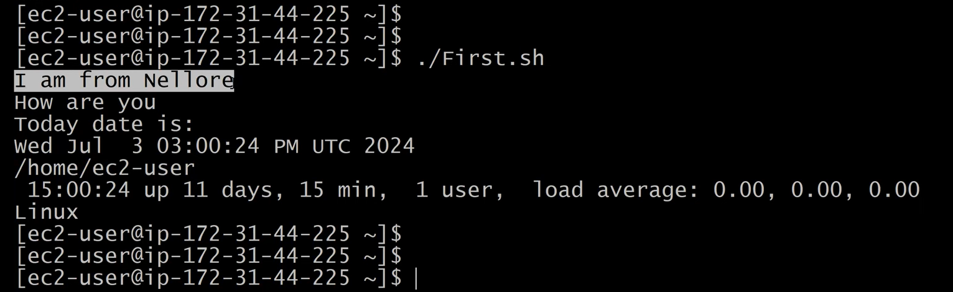
Next Lets see how to run the shell script (First.sh) in debug mode as shown in the below Image
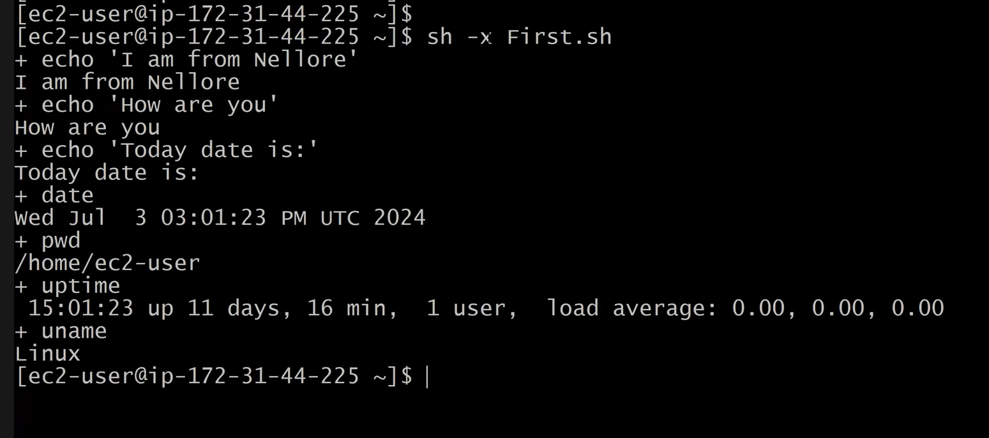
execute the command sh –x First.sh for Debug mode
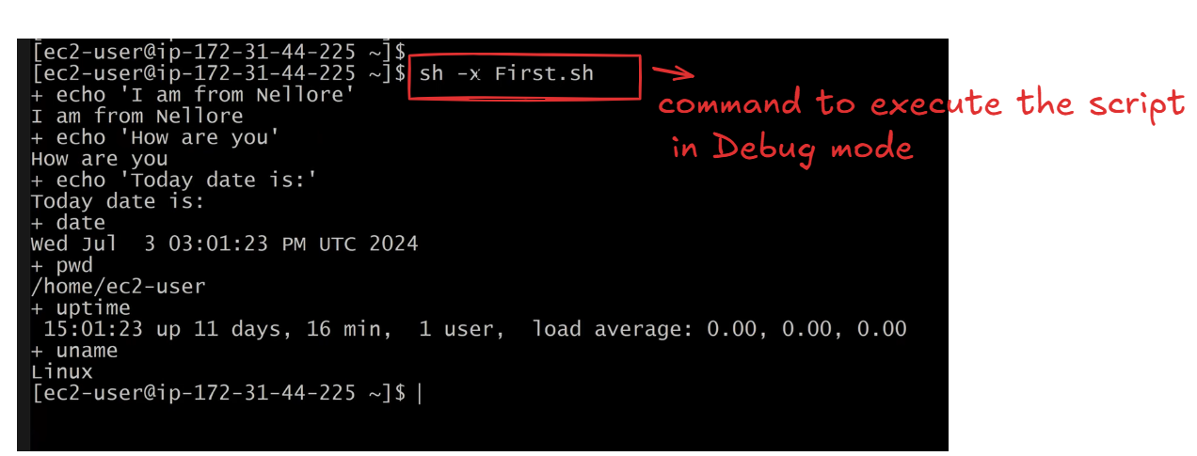
Time stamp 1:00:08
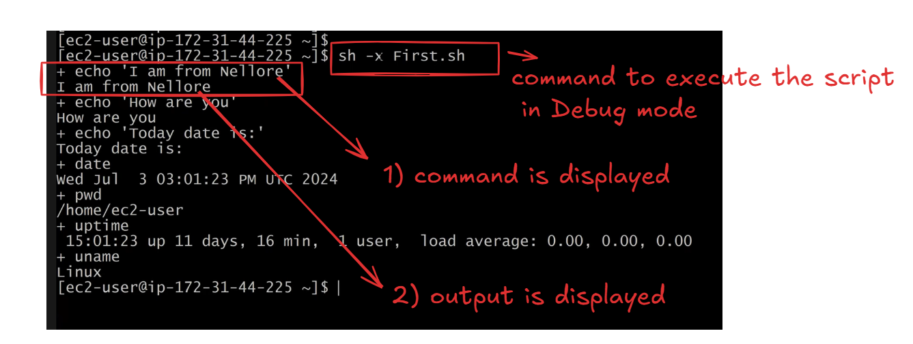
Cat the First.sh file as shown in the below Image . I want to run the specific command in the debug mode for
example I want to run the command ‘uptime’ command in debugg mode
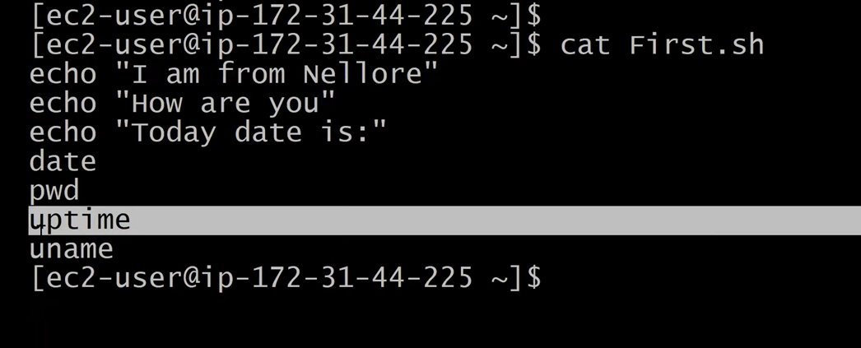
Follow the below command In order to run a command (uptime command )in the debug mode
open the First.sh and add set –x(starting debug mode) , set +x(ending debug mode)
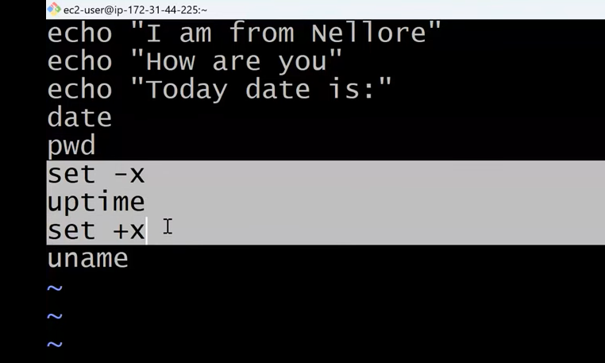
Execute the script
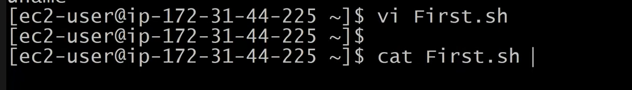
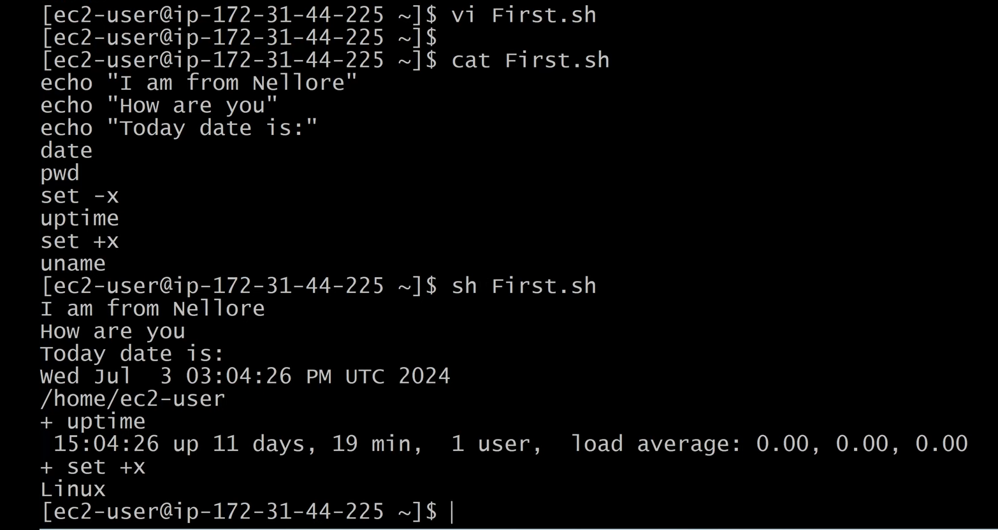
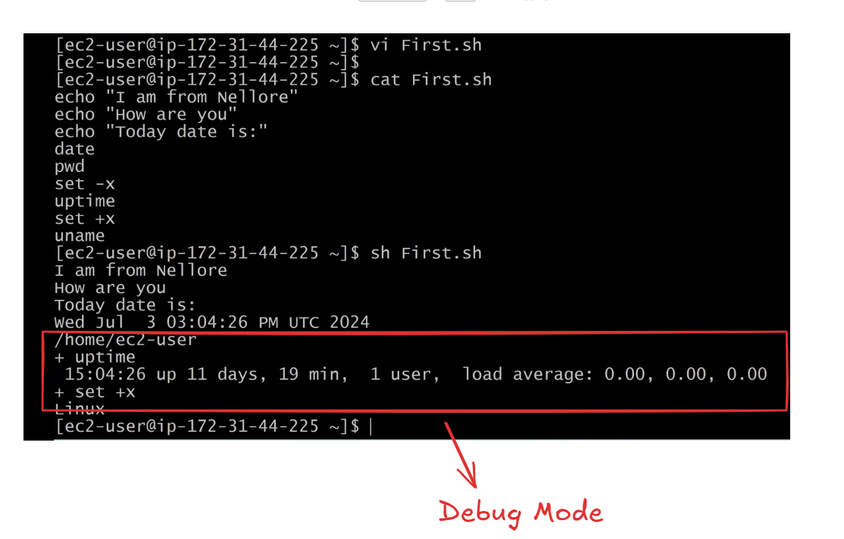
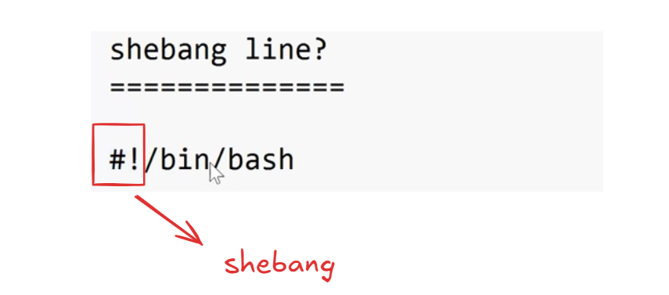
Shebang line is added at the starting of the script But it is not compulsory to have the shebang
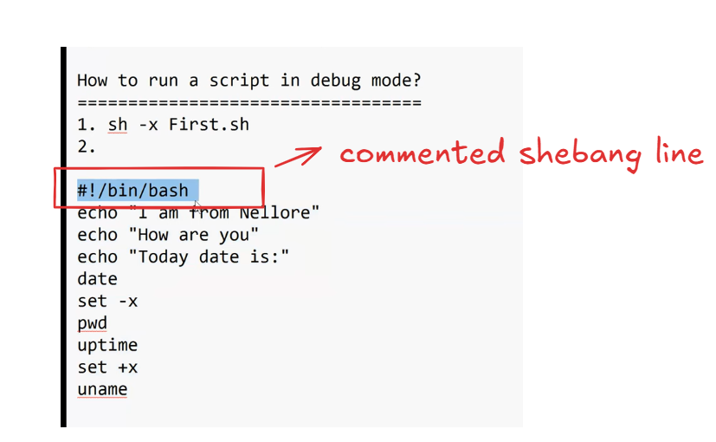
Next Topic comments in Shell Script
comments are very Important In every language we have comments
How to comment in shell script
comments are used to Improve the readability of the code
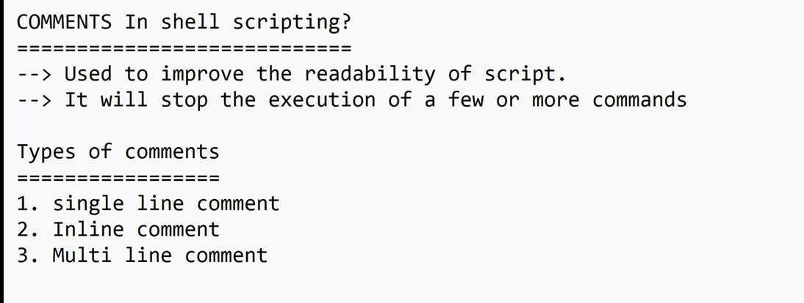
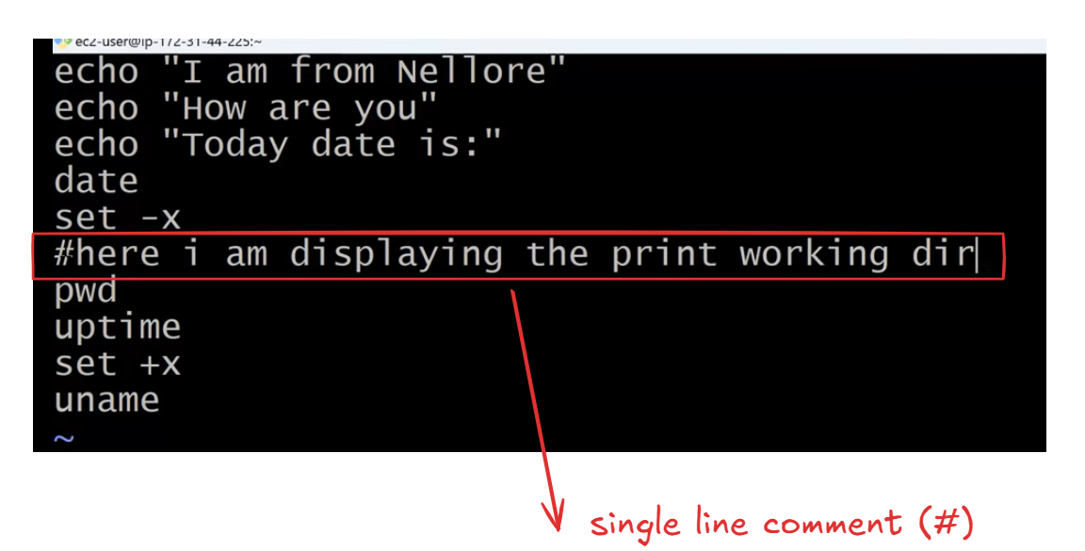
Any line that is preceded with # then that line is considered as Single line comment and ignored by the shell
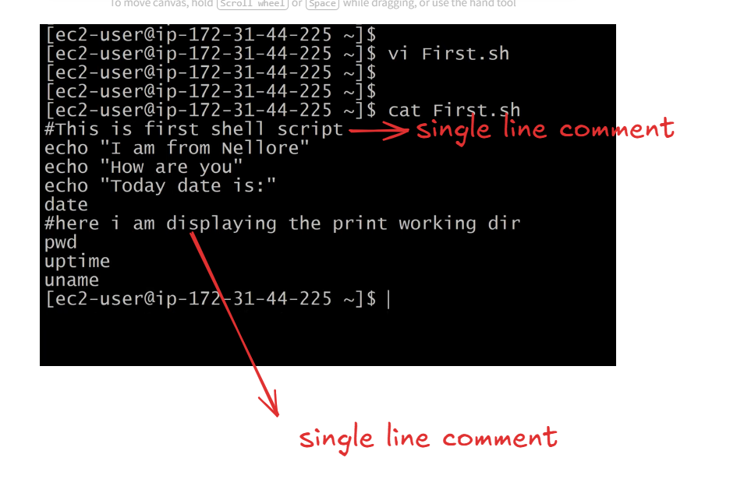
After executing the shell script which is having comments . The comment line will not be displayed in the output as shown below we are executing the First.sh script
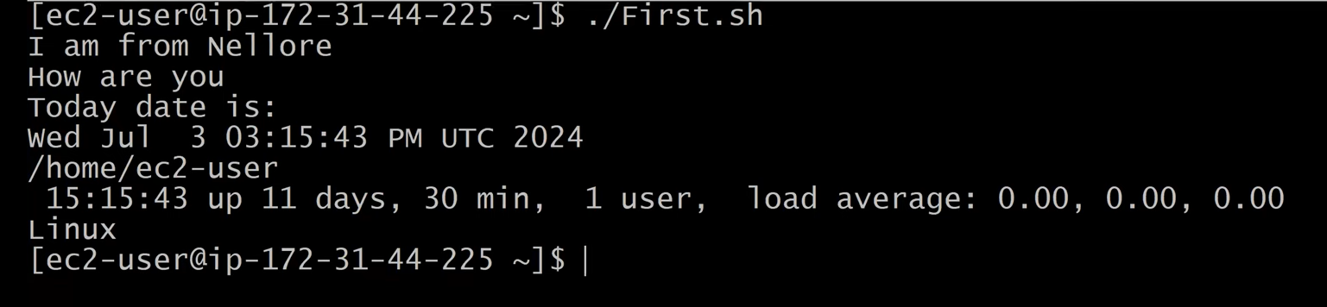
Time Stamp 1:25:00

